- Information is the refined data, data that have been put into a meaningful and useful context and communicated to a recipient who uses it to make decisions.
- It involves the communication and reception of intelligence or knowledge.
- It appraises, notifies, stimulates, reduces uncertainty, reveals additional alternatives or helps in eliminating irrelevant or poor ones and influence individuals and stimulates them to action.
- Information consists of data, images, text, documents and voice often intertwined but always organized in a meaningful context.
- 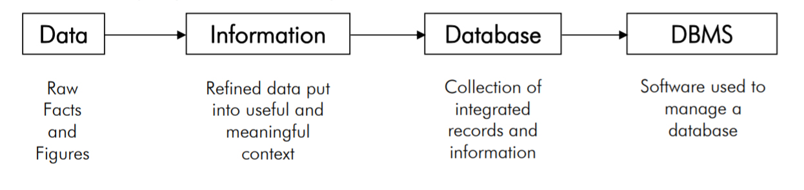
QUALITY OF INFORMATION
- Accuracy
  - Information should be error free and should clearly reflect the meaning of data on which it is based.
  - It should depict a clear picture to the recipient and may require a graphical presentation rather than tabular structure.
  - Information should be free from biasness without manipulation and distortion.
- Timeliness
  - Timeliness means delivering the information to the recipients with the needed time frame.
- Relevancy
  - Relevancy means the use of any specific information for a specific person.
  - Information relevant for one person may not be relevant for another.
ELEMENTS OF A DATABASE
- 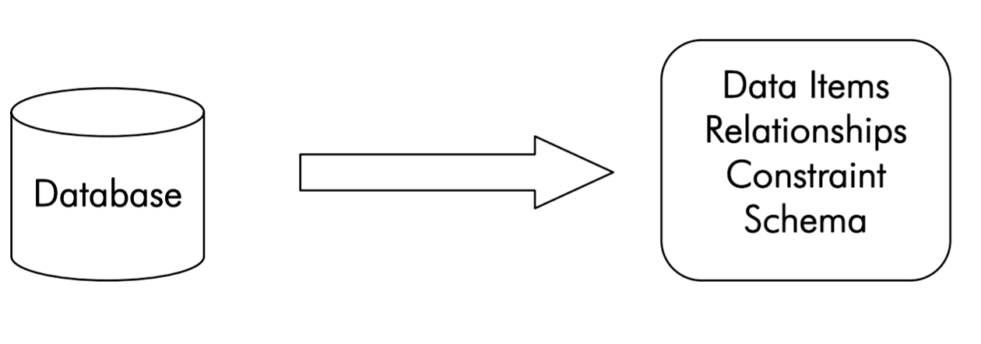
TERMS USED IN DATABASE SYSTEM
- TableA table is a part of database with rows and columns where rows are records and columns are fields.
- FileA file is a collection of data on disk accessed by a unique name.
- RecordA record is a group of related fields of information treated as a unit, an entity. Each row in a table is a record.
- FieldsThe fields of a record contain the data items, attribute of the entity. The field has its length and data type.
- Primary KeyA primary key is a unique field that identifies the records in a table. It is the key that prevents redundant data as no duplicate value possible.
- EntityAn entity is a “thing” or “object” in the real world that is distinguishable from all other objects. e.g. each person in an enterprise is an entity.
- Attribute (Fields) The individual properties of the entity, about which data is recorded are its attribute. e.g. the
attributes of Report (Entity) will include “Roll No.”, “SName”, “Class”, “Subject1”, “Subject2”, “Total”
- RelationshipA relationship is an association among several entities.
DRAWBACKS OF OLDER DATABASE SYSTEMS
- Encoded Data (data hard-coded in the application)
- Interdependence between programs and data files
- Data repetition or redundancy
- Data inconsistency (Irregularity)
- Ad hoc (Unplanned/Informal) representation of relationships
- Ad hoc data management techniques
- Lack of data security mechanisms
- Non uniform back-up and recovery methods
DATABASE AND ITS IMPORTANCE
- A database is a structured collection of records or data that is stored in a computer system. In order for a database to be truly functional, it must not only store large amounts of records well, but be accessed easily. In addition, new information and changes should also be fairly easy to input. In order to have a highly efficient database system, you need to incorporate a program that manages the queries and information stored on the system called the Database Management System. Besides these features, all databases that are created should be built with high data integrity and the ability to recover data if hardware fails.
ADVANTAGES OF DATABASE
- 1. Data redundancy can be reduced
- Data redundancy refers to the repetition of data in multiple places. This wastes the storage spaces. By using a computerized database system, redundancy can be reduced to remarkable amount. Redundancy can be removed using a primary key.
- 2. Inconsistency can be avoided
- Data becomes inconsistent when there is a redundancy error. When there is same data on two sites and changes are made at one site only without propagating to the next site, data remain inconsistent as the entries regarding the same data do not agree.
- 3. Data Sharing
- Data in a database can be shared with any existing application.
- 4. Standards can be enforced
- With the central control of the database, the database administrator can enforce standards.
- 5. Security restrictions can be applied
- The DBA can ensure the security of data by the use of a proper channel to access data. Authorization checks can be carried out while accessing sensitive data.
- 6. Integrity (Accuracy) can be maintained
- Integrity of a database refers to it accuracy and precision. A centralized control of the data helps in
permitting the administrator to define integrity constraints to the data in database.
- 7. Conflicting requirements can be balanced
- Knowing the overall requirement as opposed to the individual requirements, the database can be structured to provide an overall service that is best for the organization.
CHARACTERISTICS OF DATA IN A DATABASE
- The data in a database should have the following features.
- Shared: Shared among different users and applications
- Persistence: Data in a database exist permanently and has thoroughness.
- Validity/Integrity/Correctness: Data should be correct with respect to the real world entity that they represent.
- Security: Data should be protected from unauthorized users and access.
- Consistency: Whenever more than one data element in a database represents related real-world values, the values should be consistent (regular) with respect to the relationship.
- Non-redundant: No two data items in a database should represent the same real-world entity.
DATABASE MANAGEMENT SYSTEM
- A DBMS is a software that provides services for accessing a database, while maintaining all the required features of the data.
- A DBMS is a set of software programs that controls the organization, storage, management, and retrieval of data in a database.
- It is a set of prewritten programs that are used to store, update and retrieve a Database.
- The DBMS accepts requests for data from the application program and instructs the operating system to transfer the appropriate data.
- When a DBMS is used, information systems can be changed much more easily as the organization’s information requirements change. New categories of data can be added to the database without disruption to the existing system.
SERVICES OF DBMS
- 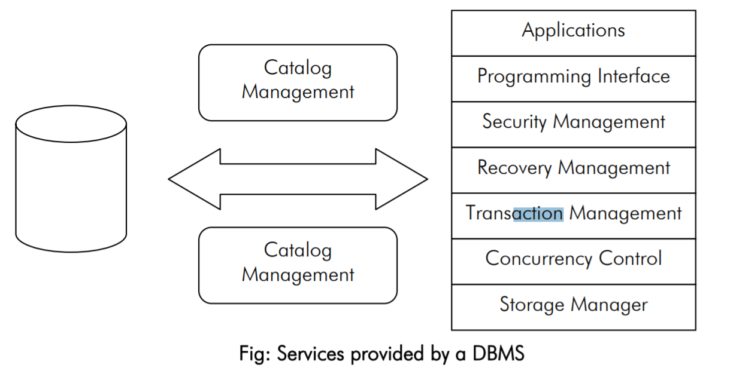
- Transaction Processing: A transaction is a sequence of database operations that represents a logical unit of work. It assesses a database and transforms it from one state to another. A transaction can update a record, delete one or modify a set of records. When a DBMS does a “commit”, the changes made by the transaction are made permanent. If a user does not want to make the change permanent, he can rollback the transaction and the database will remain in its original state.
- Concurrency Management: It is the database management activity of coordinating the actions of database manipulation processes that operates concurrently, access shared data and can potentially interfere with each other. The goal of an ideal concurrency management mechanism is to allow concurrency while maintaining the consistency of the shared data.
- Recovery: The objective of recovery in a database is to ensure that the aborted of failed transactions do not create any adverse effect on the database or other transactions. It makes sure that the database is returned to a consistent state after a transaction fails or aborts. Recovery is a very much related to concurrency in the sense that, the more the concurrency, the more is the chance of an aborted transaction affecting many other transactions.
- Security: Security refers to the protection of data against unauthorized access. Security mechanisms make sure that only authorized users are given access to the data in the database. The level of access is for each user and the operations that each user can perform on the data will be monitored and controlled by the DBMS depending on the access privileges of the users.
- Language Interface: The DBMS provides support languages used for the definition and manipulation of the data in the database. By providing language support for data definition and manipulation the DBMS create an environment where the users can do their jobs without worrying about the physical implementation.
- Data Catalog: Data catalog or Data Dictionary is a system database that contains the descriptions of data in the database (metadata). It contains information about data, relationship, constraints and the entire schema that organize these features into unified database. It also gives the information about the structure of the database.
- Storage Management: The DBMS provides a mechanism for the management of permanent storage of the data.
DATABASE MODELS
Hierarchical Model
- 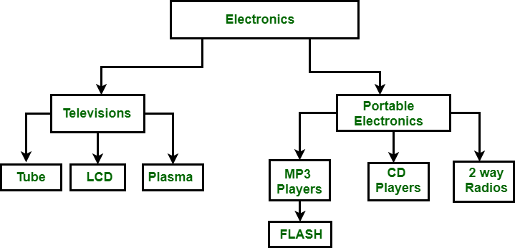
- The hierarchical data model organizes data in a tree structure. There is a hierarchy of parent and child data segments. This structure implies that a record can have repeating information, generally in the child data segments. Data is a series of records, which have a set of field values attached to it. It collects all the instances of a specific record together as a record type. These record types are the equivalent of tables in the relational model, and with the individual records being the equivalent of rows. To create links between these record types, the hierarchical model uses Parent Child Relationships. These are a 1:N mapping between record types. This is done by using trees, like set theory used in the relational model, “borrowed” from math.
- For example, an organization might store information about an employee, such as name, employee number, department, salary. The organization might also store information about an employee’s children, such as name and date of birth. The employee and children data forms a hierarchy, where the employee data represents the parent segment and the children data represents the child segment. If an employee has three children, then there would be three child segments associated with one employee segment. In a hierarchical database the parent-child relationship is one to many. This restricts a child segment to having only one parent segment.
Network Model
- 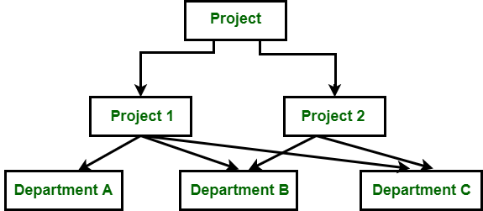
- The popularity of the network data model coincided with the popularity of the hierarchical data model. Some data were more naturally modeled with more than one parent per child. So, the network model permitted the modeling of many-to-many relationships in data. In 1971, the Conference on Data Systems Languages (CODASYL) formally defined the network model. The basic data modeling construct in the network model is the set construct. A set consists of an owner record type, a set name, and a member record type. A member record type can have that role in more than one set, hence the multiparent concept is supported. An owner record type can also be a member or owner in another set. The data model is a simple network, and link and intersection record types (called junction records by IDMS) may exist, as well as sets between them. Thus, the complete network of relationships is represented by several pairwise sets; in each set some (one) record type is owner (at the tail of the network arrow) and one or more record types are members (at the head of the relationship arrow). Usually, a set defines a 1:M relationship, although 1:1 is permitted. The CODASYL network model is based on mathematical set theory.
Relational Model
- 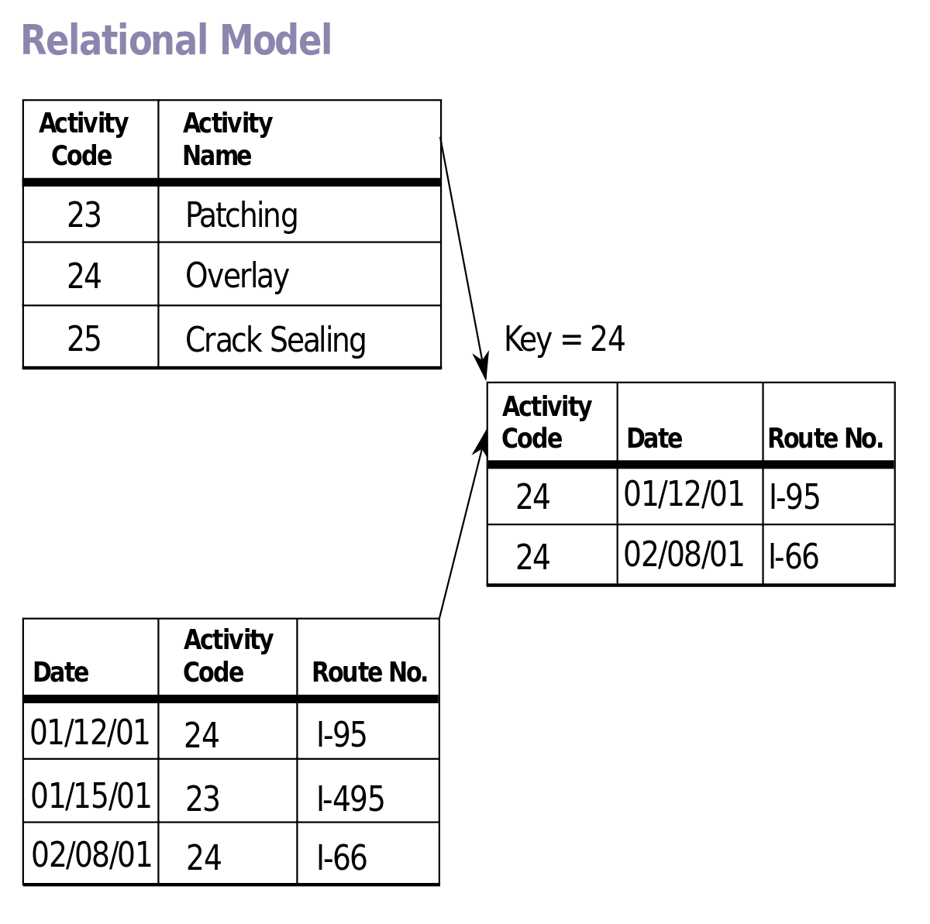
- Developed by E.F. Codd, a relational database allows the definition of data
structures, storage and retrieval operations
and integrity constraints. In such a
database the data and relations between
them are organized in tables. A table is a
collection of records and each record in a
table contains the same fields.
- Properties of Relational Tables:
- Values Are Atomic
- Each Row is Unique
- Column Values Are of the Same Kind
- The Sequence of Columns is Insignificant
- The Sequence of Rows is Insignificant
- Each Column Has a Unique Name
- Certain fields may be designated as keys, which mean that searches for specific values of that field will use indexing to speed them up. Where fields in two different tables take values from the same set, a join operation can be performed to select related records in the two tables by matching values in those fields. Often, but not always, the fields will have the same name in both tables. For example, an “orders” table might contain (customer-ID, product-code) pairs and a “products” table might contain (product-code, price) pairs so to calculate a given customer’s bill you would sum the prices of all products ordered by that customer by joining on the product-code fields of the two tables. This can be extended to joining multiple tables on multiple fields. Because these relationships are only specified at retrieval time, relational databases are classed as dynamic database management system. The RELATIONAL database model is based on the Relational Algebra.
Object-Oriented Model
- 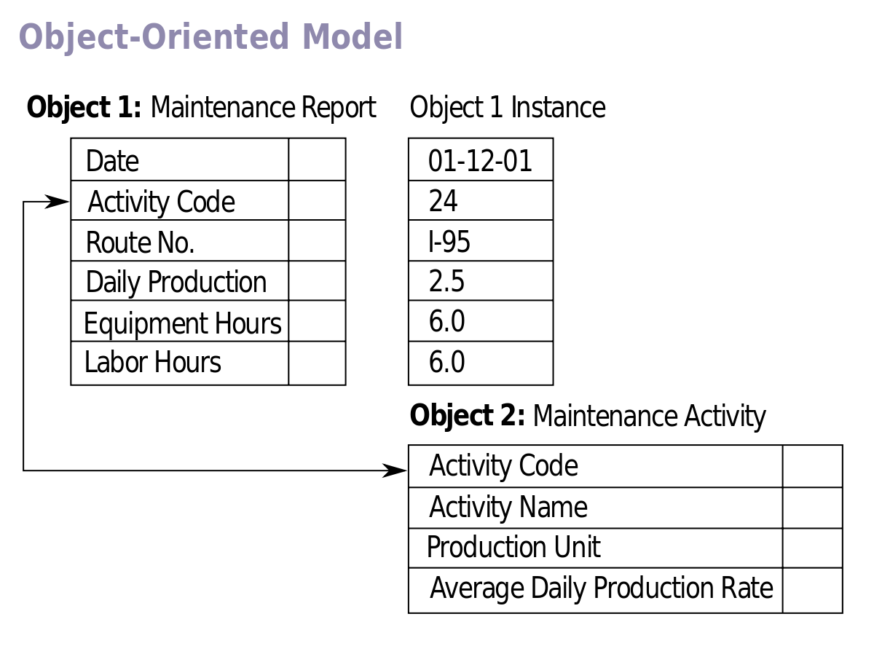
- Object oriented DBMS add database functionality to object programming languages. They bring much more than persistent storage of programming language objects. Object oriented DBMS extends the semantics of the C++, Smalltalk and Java object programming languages to provide full-featured database programming capability, while retaining native language compatibility. A major benefit of this approach is the unification of the application and database development into a seamless data model and language environment. As a result, applications require less code, use more natural data modeling, and code bases are easier to maintain. Object developers can write complete database applications with a modest amount of additional effort.
- In contrast to a relational DBMS where a complex data structure must be flattened out to fit into tables or joined together from those tables to form the in-memory structure, object DBMSs have no performance overhead to store or retrieve a web or hierarchy of interrelated objects. This one-to-one mapping of object programming language objects to database objects has two benefits over other storage approaches: it provides higher performance management of objects, and it enables better management of the complex interrelationships between objects. This makes object DBMSs better suited to support applications such as financial portfolio risk analysis systems, telecommunications service applications, World Wide Web document structures, design and manufacturing systems, and hospital patient record systems, which have complex relationships between data.

